File configuration and Verification

1. Created device inventory in .YAML

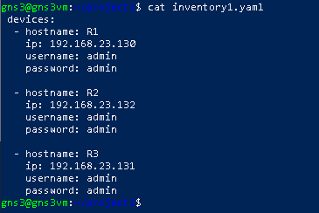
2. Recall that inventory into Python:-
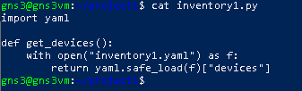

3. Used Netmiko to create backup of devices:

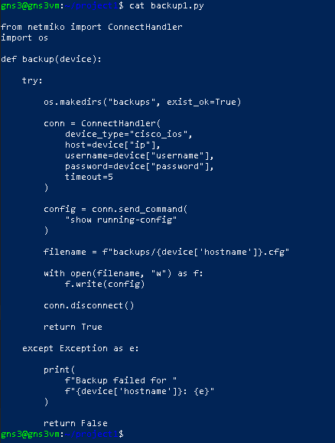

- Used Python's standard library module datetime for alerting:-

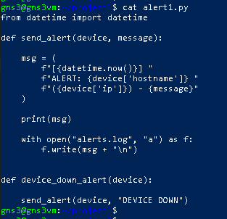

5. Used NetMiko for monitoring:-

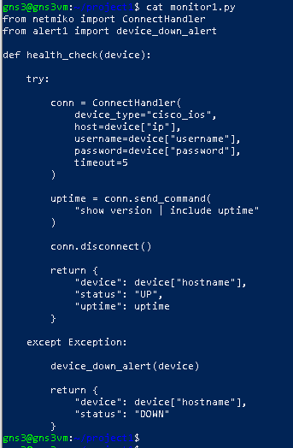

6. Used Python's built-in os module which helps to interact with the operating system

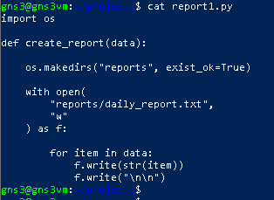
- Created simple status database for network automation project to stores device states (UP/DOWN) in a JSON file so the script can remember previous device status between next runs.

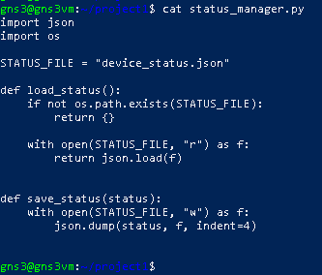

- This json file shows the devices status:
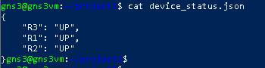

- Complete file details created for this Project:-

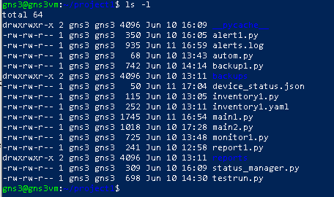

10. below is the complete configuration of Main file.
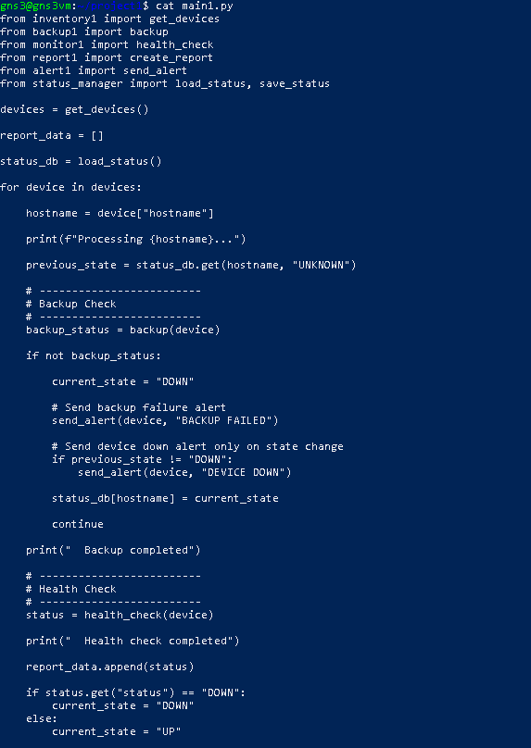

Countinue the main file configuration:-

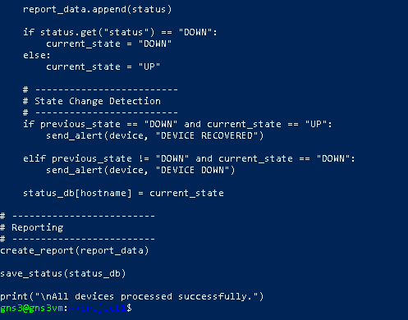
Verification:
1. Below output based on ideal scenario if all devices are up.
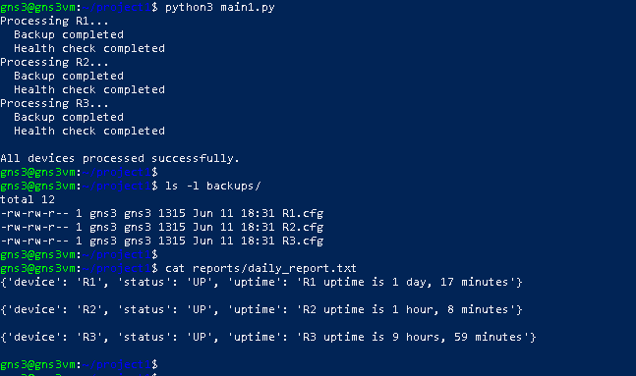

2. Below output based on R2 down:-

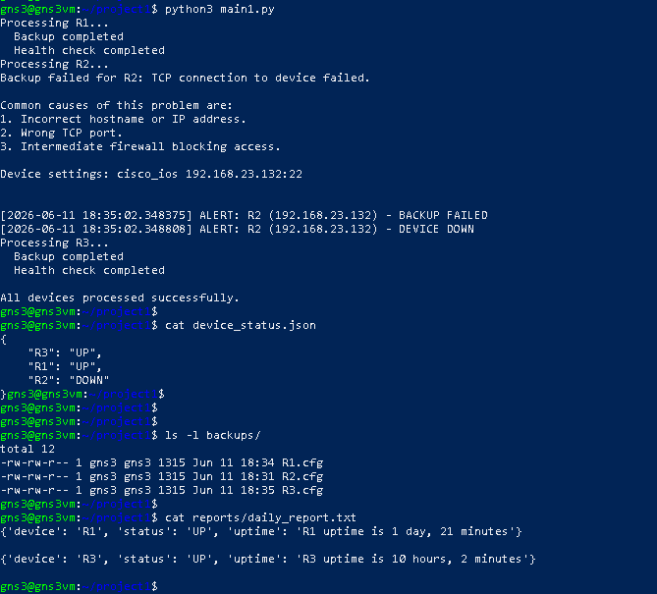

- Below output once R2 back in Production:-
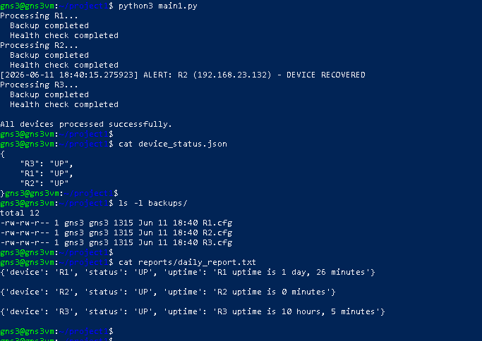

11. This is my topology which is used to complete this project
